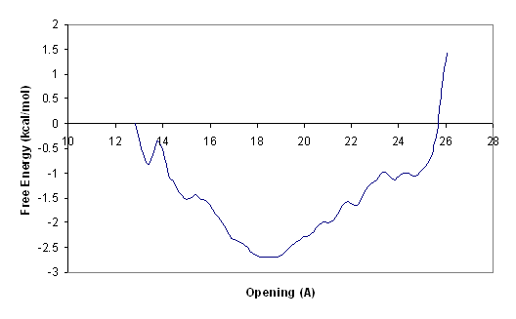
Without Bias

With Bias; k = 0.2

